Berlin, 19.8.2021

Request of support and participation for European Sepsis Care Survey

endorsed by
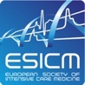
ESCMID Study Group for Bloodstream Infections, Endocarditis and Sepsis - ESGBIES

Dear Colleagues,
The European Sepsis Alliance’s mission is to fight sepsis in Europe. We are committed to change how sepsis is prioritized, diagnosed, and treated within Europe as laid out by the WHO Resolution on Sepsis.
Sepsis is the dysregulated body’s response to most infectious diseases worldwide, including COVID-19. If not recognized early and treated promptly, it may lead to shock and multi-organ failure. With about 50 million cases and 11 million deaths worldwide per year, sepsis accounts for one in five global deaths. In Europe sepsis accounts to around 3,4 million cases and almost 700.000 deaths yearly, the majority of which is preventable. However, we believe that this is an underestimation because of lack of accurate data collection and reporting remains one of the main problems in the management of sepsis.

We are writing to request your participation in the European Sepsis Care Survey. Your contribution will be crucial for the success of this project of more than 20 European countries. The objective of this survey is to investigate the current state of sepsis care around Europe, analysing procedures and protocols, quality improvement programs and quality indicators. The study will survey emergency departments, wards, intensive care units, clinical diagnostic and microbiological services.

No patient’s data are collected.
Conclusions about individual hospitals will not be drawn and not published.
Please register your hospital here.
https://sepsissurvey.sslsurvey.de/Hospital-Registration-European-Sepsis-Survey
We will send you a personal invitation by email.
One contributing person (local coordinator) from each hospital will be named as a member of the European Sepsis Care Survey Study Group. The European Sepsis Care Survey Study Group will be also listed in the author byline. All study group members will be acknowledged as collaborators and PUBMED listed in future publications.
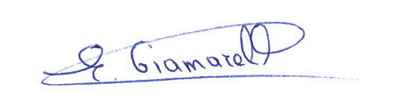
Sincerely yours,
Evangelos J. Giamarellos-Bourboulis Daniela Filipescu
Chair Vice-chair

